Programming language (I) – Homework #6
Implement the 2-D matrix multiplication by using three different 2-D arrays argument method：

- Standard method f1(int A[][c], int B[][c], int n, int m),
直接宣告二維的陣列, c is constant

- Using 1-D array to simulates 2-D array.
f2(int A[], int B[], int n, int m)
使用一維陣列來模擬二維陣列

- Using f3(int **A, int **B, int n, int m),
使用指標指向陣列，陣列每個儲存格個別再指向一維陣列。
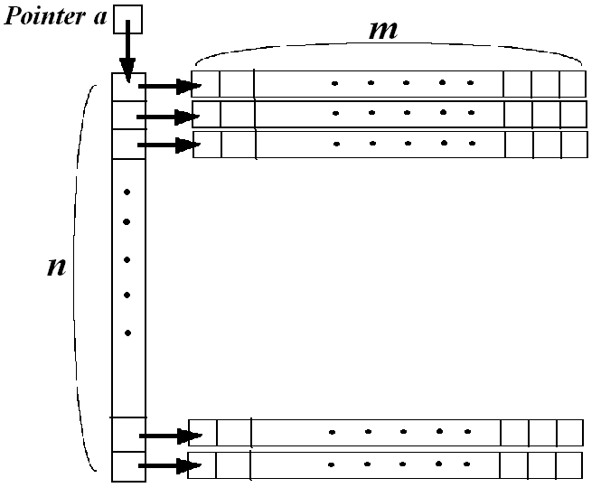

P.S.1
(a)Using argc and argv[] to input n and m.
(b)Using random number generator to generate n*m and m*n matrices of integers.

P.s.2 執行方式如下：
Ex: ./MatrixMul a n m
a : choose method(1~3).
n,m : create a matrix A_{n*m} and matrix B_{m*n}.
output: output a matrix C_{n*n} = A*B

